

Be joyful in hope, patient in affliction, faithful in prayer.
Romans 12:12

Hello!
What a great reminder that we all can have hope in the Lord while we are in our various types of prisons, that we need to be patient and not give up since God’s time is not our time, and to never stop talking to God because he will never stop listening to us. No matter what type of prison we are in we can all reach out to God for help and He is just in listening to all our prayers. However, let’s not forget to praise Him for all He has done for us because He is worthy to be praised. I don’t know about you but I’d like to share some praises for blessings the Lord has been given to this Kairos Prison Ministry:
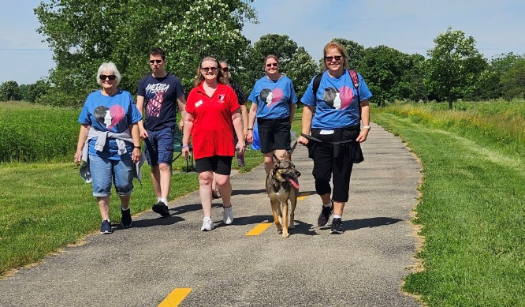
- We praise God for the generous donations given to our ministry during the Distance for Deliverance walk-a-thon last month! I have added one of the photos taken of our walkers.
- We praise God for a wonderful person who is interested in becoming our next State Financial Secretary!
- We Praise God for the opportunity to continue providing the Prisoner-to-Prisoner devotionals to the Jackson, Fox Lake, Taycheedah and Oshkosh Correctional Institutions!
- We praise God for the relations with the Ellsworth Correctional Center in Union Grove to be growing as they are working on logistics with the Kairos Inside Advisory Council for a possible Weekend program to start in God’s time
- We praise God for a group of seasoned Kairos Inside men in the Chicago area to start building a relationship with the chaplain at Racine Correctional Institution who is excited to learn more and work on logistics to have Kairos Inside start there as well!
- We praise God for all the great connections and prayers that were shared during our time at our Lifest booth!
- We praise God for 9 ladies who came forward during Lifest who want to attend the KO#8 Weekend as guests!

I would like to invite you to be a part of the Kairos Prison Ministry Annual Conference by attending the live stream of the General Sessions. Here is the link:
https://www.youtube.com/playlist?list=PLlZDBP3eJv0O2oqW41KqCQAXt4IorEKLY
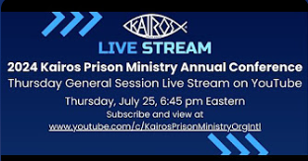
For those of you who would like to receive the Kairos Prison Ministry International newsletter called “Gods Special Time” to learn more about the impact ministry is having all across the world, you can subscribe to it by emailing marketing@kpmi.org . Believe me when I say it is an awesome newsletter!!
We also encourage you to visit https://kairoswi.org/ or https://www.kairosprisonministry.org/ as well to learn even more about this life changing ministry.
Of course where would we be if we didn’t have you all praying for this ministry! Below are some of the requests we have for you to join us in prayer for:
- Continued funds to provide institutions with Prisoner-to-Prisoner devotionals.
- For someone to come forward to take on the State Chair position so that Carlene Griffith can take on another roll in the organization at the end of 2024.
- The staffing situation in all the correctional institutions to get better soon. Not just in this state but all around our country.
- For more guests to come forward soon to attend the Kairos Outside #8 Weekend. Remember this is free to all volunteers and guests.
- For more possible volunteers to attend an upcoming Kairos Info Party at Father Carr’s Place to Be at 1062 N Koeller St, Oshkosh on August 3rd at Noon. Food and door prizes included.
- For God’s direction in calling volunteers to get Kairos Torch started in the Racine, Appleton and Milwaukee areas. Racine juvenile detention center, Lincoln Hills juvenile facility and Rawhide Boys Ranch are open to Kairos Torch being started, praise God.
- Pray for the continued opportunities for Kairos Inside to grow.
To be a part of this amazing ministry, I strongly encourage you to reach out to:
Barb Williams (barbwilliams1025@yahoo.com or 920-819-1912) to help Kairos Outside of Eastern WI Advisory Council and to refer guests to attend the next Kairos Outside Weekend
Mary Wilson (marywilson@ourjourneychurch.com or 262-989-4048) to be a part of the Advisory Council for Kairos Inside Ellsworth or to help with the possible start up of Kairos Inside of Racine
Carlene Griffith (carlenegrif@gmail.com or 920-810-9242) if you have interest Kairos Torch in other parts of the state or to help the state committee in any other way

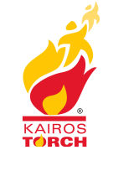
If you have interest, Kairos Torch 101 is being offered to those who are interested in learning about the program. This is a broad overview of the Kairos youth program from initial volunteer recruitment to mentoring. It is designed to give new volunteers an understanding of the requirements and key elements of Kairos torch using many visual and interactive demonstrations. Please use the links after each date to register ahead of time to attend a session. You may have to copy them and paste them into a browser.
Saturday, August 17th, 3-5:30PM CST https://kpmi-org.zoom.us/meeting/register/tZcqdOurqTgpGNYznSIost5AoK28AxZ5YFMb#/registration
Thursday, September 19th, 6-8:30PM CST https://kpmi-org.zoom.us/meeting/register/tZYrf-2vrzIiHtJzbBHaQA75Ti2D-JAeM8i5#/registration
Saturday, October 19th, Noon-2:30PM CST https://kpmi-org.zoom.us/meeting/register/tZ0lcu2qqDkqHtDxDrMn3s_MDMAEKkonMyo9#/registration
Thursday, November 14th, 3-5:30PM CST https://kpmi-org.zoom.us/meeting/register/tZAsd-GgrT0oGNcShsixtBGqbjA9GpT-u8yv#/registration
Saturday, December 14th, Noon-2:30PM CST https://kpmi-org.zoom.us/meeting/register/tZMkd-mhqzgoG9djZ-C_DVHxbZ4dRzfsv85l#/registration

I have attached a Day Angel Application, a guest registration form to give to any potential guests, an invitation to the Walking in Love service and an invite for the Kairos Info Party. Please share these opportunities with everyone you know or with those you know in your churches. Please know you are all invited to attend the State Committee meetings or any of the Advisory Council meetings without having to hold a position but to learn about what we do.
The next State Committee meeting is August 18 via Zoom at 1PM. Everyone is welcome to attend. The next Kairos Outside of Eastern WI Advisory Council will meet on July 23rd. Please reach out to Barb Williams above for meeting time and place. The next Kairos Inside of Ellsworth Advisory Council meeting is July 25th via Zoom. Please reach out to Mary Wilson above to get the link to attend.
Your prayers and support are greatly appreciated!!

